**NUST SCHOOL OF ELECTRICAL ENGINEERING AND COMPUTER SCIENCE**

|  |  |
| --- | --- |
| Faculty Member:__________________ | Lab Engineer: ______________ |
| Date:_________________________ | Semester/Section:____________ |

|  |  |
| --- | --- |
|  |  |

Department of Electrical Engineering  
EE- 222: Microprocessor Systems

**LAB 12: Switch and LED Interfacing**

|  |  |  |  |  |
| --- | --- | --- | --- | --- |
| Student’s Name | Reg. # | Lab Conduct and Report | Viva | Total |
| 10 | 5 | 15 |
|  |  |  |  |  |
|  |  |  |  |  |
|  |  |  |  |  |
|  |  |  |  |  |

## Purpose

In this lab you will design a switch to enable or disable the LED for fixed time period at PORTE.

## System Requirements

Your embedded system will:

1. Make **PE0** an output and make **PE1** an input.
2. The start with the LED on (make **PE0** =1).
3. Wait about 62 ms ( 1000ms / 16 toggles per second)
4. If the switch is pressed (**PE1** is 1), then toggle the LED once, else turn the LED on.
5. Steps 3 and 4 are repeated over and over

## Procedure

To run the Lab 12 simulator, you must do two things. First, execute Project->Options and select the Debug tab. The debug parameter field must include **-dEE319KLab3**. Second, the **EE319KLab3.dll** file must be added to your Keil\ARM\BIN folder. The **Grading Controls** are for the MOOC and are not used as actual grades in EE319K this semester.

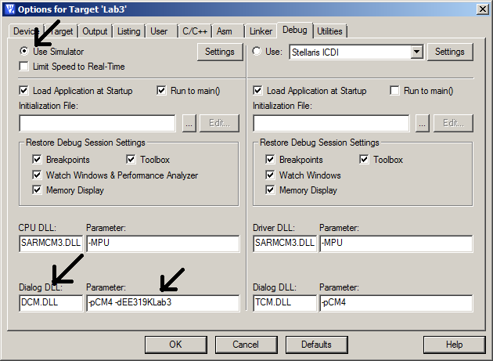

*Figure 3.1a. Using TExaS to debug your software in simulation mode (DCM.DLL -pCM4 -dEE319KLab3).*

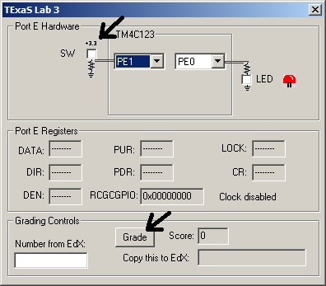

*Figure 3.1b. Click in the white box to affect the state of the switch .*

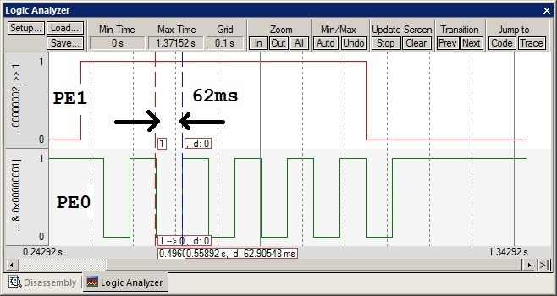

*Simulation of Lab 2, showing PE1 high, and the PE0 output toggling at 8 Hz.*